A Mini Project with Seminar
ON

A Comparative Study of ML Models for
Tumor Classification

Submitted in partial fulfillment of the requirements for the award of the

Bachelor of Technology
in

Computer Science and Engineering (Data science)
by

M. Isaac Manohar | 23241A6741
B. Sai Shiva Reddy | 23241A6704
K. Vishnu Vardhan | 23241A6733

Under the Esteemed guidance of

Dr. Aruna Kumari

Assistant Professor

Department of Data Science

GOKARAJU RANGARAJU INSTITUTE OF ENGINEERING AND TECHNOLOGY
(Approved by AICTE, Autonomous under JNTUH, Hyderabad)
Bachupally, Kukatpally, Hyderabad-500090
2025-2026


GOKARAJU RANGARAJU INSTITUTE OF ENGINEERING AND TECHNOLOGY
(Autonomous)

Hyderabad-500090

CERTIFICATE

This is to certify that the Mini Project with Seminar entitled “A Comparative Study of ML Models for Tumor Classification” is submitted by M. Isaac Manohar (23241A6741), B. Sai Shiva Reddy (23241A6704) and K. Vishnu Vardhan (23241A6733) in partial fulfillment of the award of degree in BACHELOR OF TECHNOLOGY in Computer Science and Engineering (Data science) during Academic year 2025-2026.

Internal Guide Head of the Department

Dr. Aruna Kumari Dr. S. Govinda Rao

External Examiners

ACKNOWLEDGEMENT

There are many people who helped us directly and indirectly to complete our project successfully. We would like to take this opportunity to thank one and all. First, we would like to express our deep gratitude towards our internal guide Dr. Aruna Kumari, Assistant Professor, Department of Data Science, for her support in the completion of our dissertation. We are thankful to our major project coordinators Mr. K. Mallikarjuna Raju, Assistant Professor and Ms. Srilatha, Assistant Professor, for there valuable suggestions and comments during this project period.
We wish to express our sincere thanks to Dr. S. Govinda Rao, Head of the Department, and to our principal Dr. J. PRAVEEN, for providing the facilities to complete the dissertation. We would like to thank all our faculty and friends for their help and constructive criticism during the project period. Finally, we are very much indebted to our parents for their moral support and encouragement to achieve goals.

M. Isaac Manohar (23241A6741)
B. Sai Shiva Reddy (23241A6704)
K. Vishnu Vardhan (23241A6733)

DECLARATION

We hereby declare that the major project titled “A Comparative Study of ML Models for Tumor Classification” is the work done during the period from 16th January 2025 to 13th May 2025 and is submitted in the partial fulfillment of the requirements for the award of degree of Bachelor of Technology in Computer Science and Engineering (Data science) from Gokaraju Rangaraju Institute of Engineering and Technology (Autonomous under Jawaharlal Nehru Technology University, Hyderabad). The results embodied in this project have not been submitted to any other University or Institution for the award of any degree or diploma.

M. Isaac Manohar (23241A6741)
B. Sai Shiva Reddy (23241A6704)
K. Vishnu Vardhan (23241A6733)

ABSTRACT

This project involves comparing the machine learning models in order to classify tumors with the objective to improve the reliability and accuracy of medical diagnosis. The studies involve processing database and medical data, feature of interest recognition, and various machine learning models, such as Support Vector Machine (SVM) and Random Forest.
A fundamental area of interest of the project is the Model Optimization Module whereby hyperparameter optimization is done by performing a grid search on the model to maximize performance by optimising the model parameters like SVM kernels and random forest estimators. The performance of the model is examined using both tuned and untuned models in order to understand the ways of learning optimization. Moreover, a comprehensive Performance Evaluation Layer will be implemented in which the Accuracy, Precision, Recall, and F1-Score measures will be implemented to establish the performance of the models. False Positives and False Negatives can be predicted with the assistance of tools, including Confusion Matrix, but ROC curves and AUC scores could help to comprehend that the model is able to classify information in medical situations.
The results allow concluding that better-than-baseline optimized models outperform baseline models in terms of stability and predictive accuracy. Overall, this project has proved that appropriate model selection, optimization and testing are core in the development of effective tumor classification models, which may assist in making improved healthcare application decisions.

LIST OF FIGURES

Figure No. | Figure Name | Page No.
1 | Literature review summary

LIST OF TABLES

Table No. | Table Name | Page No.
1 | Machine learning models used
2 | Evaluation Metrics

LIST OF ACRONYMS

TABLE OF CONTENTS

Chapter No. | Chapter Name | Page No.
 | Title | i
 | Certificate | ii
 | Acknowledgement | iii
 | Declaration | iv
 | Abstract | v
 | List of Figures | vi
 | List of Tables | vii
 | List of Acronyms | viii
1 | INTRODUCTION
2 | LITERATURE SURVEY
3 | PROPOSED METHOD
4 | RESULTS AND DISCUSSIONS
5 | CONCLUSION AND FUTURE ENHANCEMENTS
6 | REFERENCES
 | APPENDICES

CHAPTER 1

INTRODUCTION

1.1 Background and Context
The fast development of healthcare technologies has contributed greatly to the accuracy of diagnosis and care of patients. Machine Learning (ML) has become one of these innovations that can be used to interpret complex medical data. One of the most significant uses of ML is tumor classification because early cancer detection can significantly increase the survival rate and treatment outcomes.
A tumor refers to an irregular increase of cells which can either be benign or malignant. Benign tumor is non-cancerous and it does not spread whereas malignant tumor is cancerous and can invade surrounding tissues and spread or metastasize to other body parts. Correct differentiation between the two types is essential in the establishment of the proper treatment plans.
The conventional methods of diagnosis involve the use of radiologists and pathologists to read medical images like MRI, CT scans, and biopsy samples. Yet, such techniques have such shortcomings as human error, subjectivity and time constraints. As more data on medicine is generated, there has been a necessity to have automated systems that are capable of aiding in making accurate and swift decisions.
Machine learning algorithms are able to handle large data sets, learn trends and make predictions at high accuracy. A number of algorithms including Support Vector Machines (SVM), Random Forest, Decision Trees and K-Nearest Neighbors (KNN) have been successfully employed to solve tumor classification problems over the years. The current project is based on these developments and aims to compare the various ML models.
Moreover, machine learning use in tumor classification not only improves the accuracy of the diagnosis but also aids clinical decision-making with the help of data-driven information. As more medical data becomes publicly accessible and computers gain the computational power to support it, ML models can be trained and optimized via continuous training and optimization methods like hyperparameter tuning. These models can determine hidden patterns and correlations which human experts might not easily observe. Consequently, the implementation of ML-based diagnostic systems may result in quicker. analysis, reduced workload for healthcare professionals, and improved consistency in tumor detection, thereby contributing to more effective and personalized treatment planning.

1.2 Problem Statement
The correct and early diagnosis of tumor is a prerequisite to proper treatment of cancer and its subsequent survival in a patient. Conventional diagnostic tools depend on manual processing of medical data and could be slower and have a high likelihood of being inaccurate. As medical data set keeps growing, the repeating pattern of intricate and efficient analysis of tumor features has been complicated. Despite the popularity of Machine Learning methods to detect tumors, most of them are studied in small models and do not involve a systematic comparison under standardized conditions. Consequently, an automated and systematic framework that analyses several ML algorithms and chooses the most trustworthy model to classify tumors is necessary in order to help medical decision-making.
The classification of tumor is a complex procedure because of various factors that influence the accuracy and reliability of tumor diagnosis. Among the major problems are:
High Dimensional Data: Medical data typically have a lot of features, and it can be challenging to know the most significant features.
Data Imbalance: In most datasets, the proportion of malignant cases is much smaller, the proportion of benign cases is much larger, thus contributing to biased predictions.
Difference in Tumor Characteristics: Tumor sizes, shapes, texture and location vary and thus it is complicated to classify.
Noise and Missing Data: Medical data can have missing or noisy data that can impact the model performance.
Reliance on Expert Knowledge: Traditional approaches highly depend on domain experts, and this is not always the case.
Because of these issues, multiple machine learning models need to be assessed and the one that enhances the best results under the particular conditions identified. This project solves this issue by comparing different ML algorithms on standardized evaluation metrics.

1.3 Aim and goal of the proposed work
Purpose
This project is mainly aimed at creating an effective and successful mechanism of classifying tumors with the help of machine learning. The experiment targets to compare various ML algorithms to find out their efficacy when categorizing tumors as benign or malignant. Through the use of computational intelligence, the proposed system will decrease human reliance in diagnosis and will help the medical workers make decisions faster and more intelligently.
Moreover, this work focuses on enhancing diagnostic accuracy by using preprocessing techniques, feature selection techniques, and model optimization techniques. The system is developed to process complex medical data and outliers meaningful patterns that will be used to classify data accurately. The comparative analysis also contributes to the realization of the best model to be used in various conditions, and then offer useful insights in future studies and practical use.
Objectives
To generate and test several Machine Learning algorithms, such as Logistic Regression, Support vector machine (SVM), K-Nearest Neighbors (KNN), Decision Tree, and Random Forest to classify the tumors.
To normalize tumor dataset features to get the features they have to be used to preprocess and standardize the features of the dataset so that model evaluation can be fair and consistent.
To analyze the performance of a model based on different measures like Accuracy, Precision, Recall and F1-Score on overall evaluation.
To compare the behavior of the model averaging in terms of computational efficiency, stablity and overfitting when the experiment is the same.
To determine the most trustworthy and effective ML algorithm to separate benign and malignant tumors.
The project goals can be divided into the following categories: teenage, analytical and performance-based:
Technical Objectives
To obtain and pre-treat tumor-related data to process the missing values, noise, and inconsistencies.
To apply the different machine learning models, including, Logistic Regression, SVM, Decision Tree, Random Forest, KNN and Naive Bayes.
To apply feature selection and normalization to optimize model performance.
To divide the data into training and testing sample to evaluate it appropriately.
Analytical Objectives
To compare the performance of various machine learning models using the same data.
To examine the impact of feature selection and preprocessing on model performance.
To check the strengths and weaknesses of all algorithms.
To find patterns and trends in classification outputs.
Performance Based Objectives
To compare models based on standard performance measures, like accuracy, precision, recall and F1-score.
To compare tuned versus untuned model to evaluate improvement.
To choose the most effective model with quantitative results.
Expected Outcomes
Determination of the best and most trustworthy machine learning model to classify tumors.
Better insight into the performance of various algorithms with medical data.
A flexible and adaptable architecture to improve medical diagnosis systems in the future.

1.4 Scope of the Proposed Work Revised
The scope of the project determines what the project will cover and what it will not cover when we use machine learning methods to classify tumors.

Inclusions:
We will use a type of machine learning called machine learning model like Logistic Regression, SVM, Decision Tree, Random Forest, KNN and Naive Bayes to classify tumors by machine learning methods.
We will use datasets that are based on MRI images to extract features and classify them using machine learning methods.
We will make sure the data is good to use by doing things like making all the numbers dealing with missing values and making sure the features are on the same scale.
We will take the data from the MRI images and turn it into numbers that a computer can understand using medical imaging data feature extraction to transform visual data into numerical data.
We will compare how well different machine learning models work on the data to classify tumors by machine learning methods.
We will use measures, like how accurate the models are, how precise they are, how well they remember things and something called the F1-score to see how well the models are doing to assess the performance of the machine learning models.

Exclusions:
We will not use learning models that can look at MRI images without any help to classify tumors by machine learning methods like something called Convolutional Neural Networks or CNNs.
We will not try to use the project in a real hospital setting or connect it to hospital systems to classify tumors by machine learning methods.
We will not use complicated deep learning models that need a lot of power to run to classify tumors by machine learning methods like things called ResNet or VGG.
We will not try to connect the project to devices that can monitor peoples health using something called the Internet of Things or IoT to classify tumors by machine learning methods.

1.5 Methodology and Approach
The proposed system is systematic and is based on a structured approach to carry out tumor classification through machine learning in the proposed system. The method entails several steps beginning with data collection up to the ultimate model analysis and comparison.
In-depth Methodology description.

Architecture Diagram

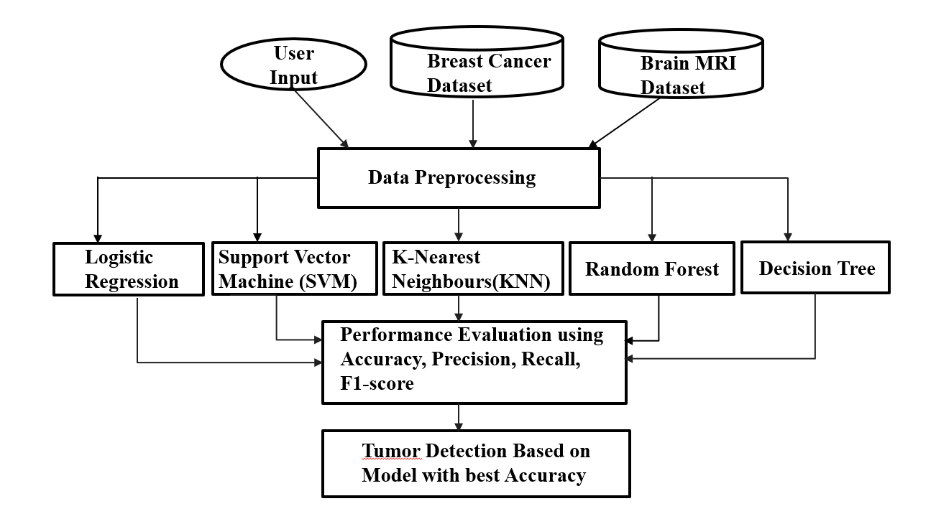

1. Dataset Collection
The data in this project is based on MRI (Magnetic Resonance Imaging) images of tumors. These images have visual data concerning the tumor characteristics in terms of size, shape, and texture.

2. Image Preprocessing
Priority to the extraction of features, MRI images are preprocessed to enhance quality and consistency:
Filtering to remove noise.
Image normalization and image resizing.
Development of contrast to improve visibility.
Removal of irrelevant background information
This is done to make sure that the images are extractable to features.

3. Feature Extraction
The next step is feature extraction in which the relevant information is extracted out of the MRI images and transformed into numbers.
Features extracted can be:
There are texture characteristics (e.g. contrast, homogeneity)
Change in shape (e.g. area, perimeter)
Intensity features (pixel values)
These characteristics are the tumor characteristics in a tabular form.

4. Dataset Formation
Once the features are extracted, then the data can be structured into a structured dataset:
The rows correspond to individual samples (patients/images).
Columns represent extracted features
Target variable: Tumor type (Benign or Malignant)
It is then trained in machine learning models with this dataset.

5. ML Preprocessing (ML Stage)
The formatted data is further preprocessed:
Handling missing values
Feature scaling (Normalization or Standardization)
Elimination of unnecessary or insignificant features.
This enhances model performance and accuracy.

6. Train-Test Split
The data is split into:
Training set (e.g. 80%) to train models.
Test set (e.g. 20%) which is used to test models.
This guarantees fair evaluation of performance.

7. Model Training
Multiple machine learning models are trained on the dataset:
Logistic Regression
Support Vector Machine (SVM)
Decision Tree
Random Forest
K Nearest Neighbours
Naive Bayes
Both models acquire patterns using the data to categorize tumors.

8. Hyperparameter Tuning
GridSearch CV is used to tune hyperparameters in order to enhance model performance:
Optimizes parameters such as SVM kernel and C value.
Changes number of trees in Random Forest.

9. Model Evaluation
The results of every model are measured in terms of common indicators:
Accuracy
Precision
Recall
F1-Score

Table 1: Machine Learning Models Used

S.NO | Model | Advantages | Limitations
1 | Logistic Regression | Simple and fast | Limited to linear data
2 | SVM | High accuracy | Computationally expensive
3 | Decision Tree | Easy to interpret | Overfitting
4 | Random Forest | High accuracy & robust | Complex model
5 | KNN | Simple implementation | Slow for large datasets
6 | Naïve Bayes | Fast and efficient | Assumes independence

Table 2: Evaluation Metrics

Metric | Formula | Significance
Accuracy | (TP + TN) / (TP + TN + FP + FN) | Overall correctness
Precision | TP / (TP + FP) | Reliability of positive predictions
Recall | TP / (TP + FN) | Ability to detect actual positives
F1-Score | 2PR / (P + R) | Balance between precision & recall

CHAPTER 2

LITERATURE SURVEY

2.1 Overview of the Current Methodologies.

Machine learning has become a prominent focus of tumor classification over the past few years because of the development of medical imaging and computational mechanisms. The current literature (2022 and later) is concerned with the optimization of the classification error through the integration of feature extraction, and sophisticated machine learning algorithms.
A number of researchers have used Support Vector Machine (SVM) to classify tumors based on MRI-based features. The methods are very precise, particularly in conjunction with feature selection methods including Principal Component Analysis (PCA). The performance of SVM, however, requires appropriate parameter tuning.
The recent publications also indicate the usefulness of Random Forest algorithms that are more generalized and robust. These architectures are effective at working with complex data and in avoiding overfitting with ensemble learning algorithms.
K-Nearest Neighbors (KNN) has been applied in certain works because of its simplicity and appropriateness with small to medium size datasets. Nonetheless, recent studies have shown that KNN is computationally infeasible with large datasets.
Lightweight systems have also used naive bayes classifiers in cases where computational efficiency is needed. Fast but with relatively lower accuracy because of independence assumptions, these models are used.
The use of hybrid models, with feature extraction mixed with optimization of machine learning algorithms, is also considered a recent development (2022-2024). These composite models have demonstrated better performance than the single models.
Deep learning methods like CNNs have been studied to directly classify images. These models are highly accurate but have high computation and data requirements, which is why they cannot be used on smaller scale projects.
In general, the recent studies indicate that the most optimal combination of feature extraction and optimized machine learning models can be used to achieve the best results in tumor classification problems.

Medical Diagnosis using Logistic Regression (2023)
  - Binary tumor classification with the help of Logistic Regression.
  - Is a linear model of base.
  - Gives coefficients of features that are interpretable.
  - Moderate accuracy on structured data.
  - Works with linearly separable data.
  - low performance in nonlinear (complex) patterns.

K Nearest Neighbours in Tumor Classification (2023)
- Uses distance-based learning to predict tumors.
- Non-parametric and simple approach.
- Works on small and clean datasets.
- Accuracy requires optimum K selection.
- Sensitive to feature scaling.
- Slow prediction on large datasets.

Cancer Detection using Support Vector Machine (2023).
  - SVM is used with high dimensional tumor data.
  - Successful in dealing with multifaceted decision frontiers.
  - Has high accuracy with an appropriate choice of kernel.
  - Needs sensitive hyperparameter tuning.
  - Cost to compute is directly proportional to the size of the dataset.

Machine Learning Methods of Brain Tumor Classification (2023)
  - Compares MRI features on classical ML models.
  - SVM presented stable and consistent results.
  - Emphasizes importance of preprocessing.
- Limited data size impacts generalization.
- Feature extraction through usage of texture, shape.

Random Forest-Based Tumor Prediction Model (2024)
  - Uses ensemble learning to classify tumors.
  - Eliminates overfitting that is found with Decision Tree.
  - Has high precision and recall.
  - Processes high-dimensional features.
  - Not as interpretable as simple models.

Deep Learning Brain Tumor Classification (2024).
  - Uses Convolutional Neural Networks .
  - Automatically extracts features from MRI images.
  - More precise than the traditional ML models.
  - Needs voluminous annotated image datasets.
- High computational and GPU needs.

Analysis of Ml Algorithms for Breast Cancer Diagnostics (2024)
  - Utilizes various assessment tools.
  - Random Forest had the best overall performance.
  - Shows significance of model comparison.
  - Limited hyperparameter optimization

Comparison of ML and DL models in cancer (2024)
- Evaluates both classical ML and deep learning approaches.
- Accuracy, Precision, Recall and , F1-score.
- Deep learning works well with big data.
- Fails to normalize the preprocessing between models.

Deep Learning and Hybrid ML Models to detect tumors (2025).
- Integrates deep learning features with ML classifiers.
- Increases the quality of classification in general.
- Uses feature fusion techniques.
- Enhances generalization capability.
- Increases model complexity.

Explainable AI in Medical Tumour Classification (2025)
  - Combinates explainable AI with tumor classifiers.
  - Gives interpretation of model predictions.
  - Enhances the confidence in AI-based medical systems.
  - Has competitive classification performance.
  - Introduces complexity in computation and implementation.

Literature Review Summary:

Figure 01:
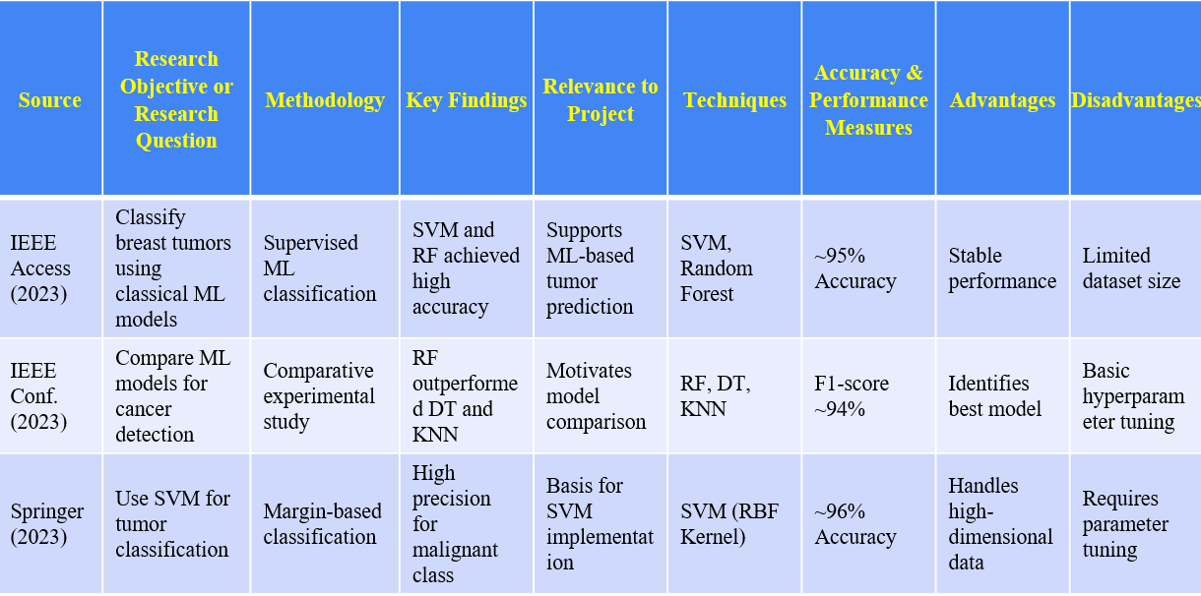
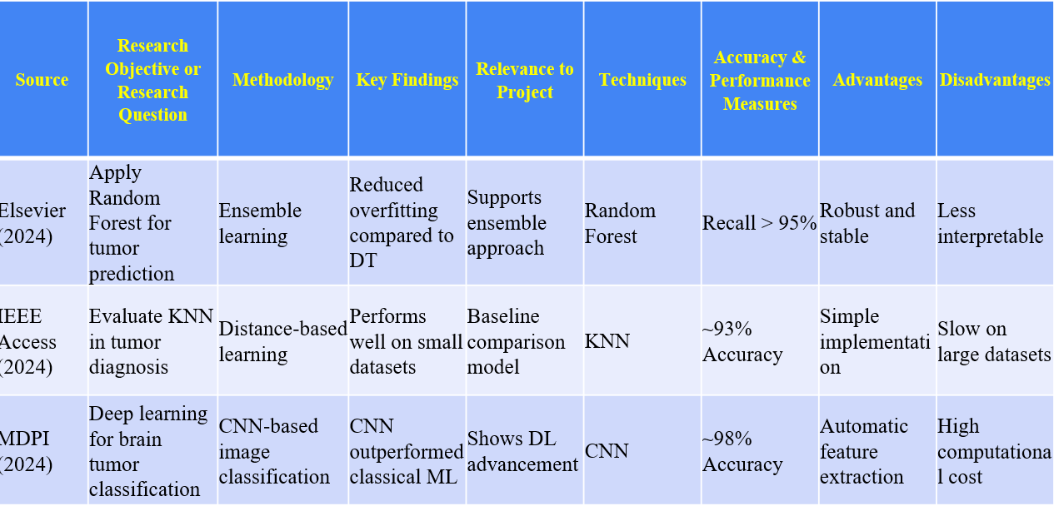

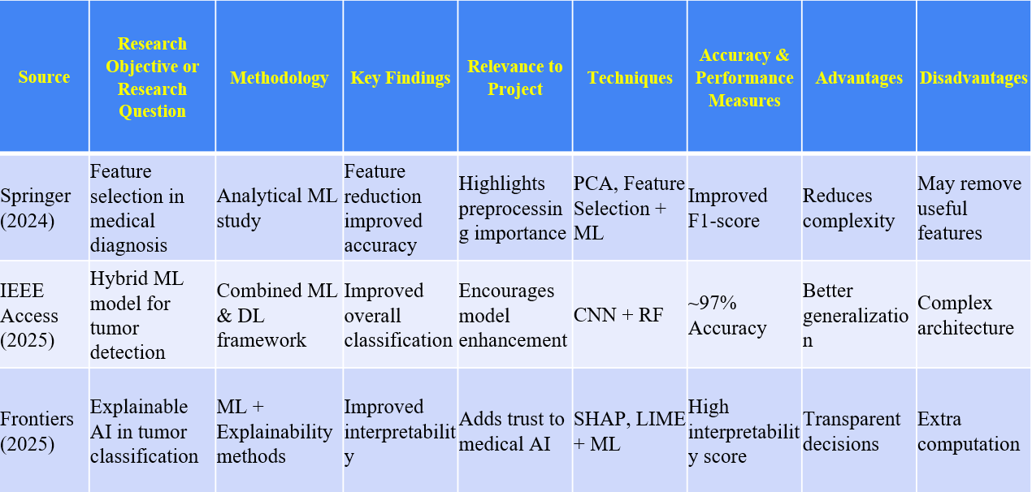
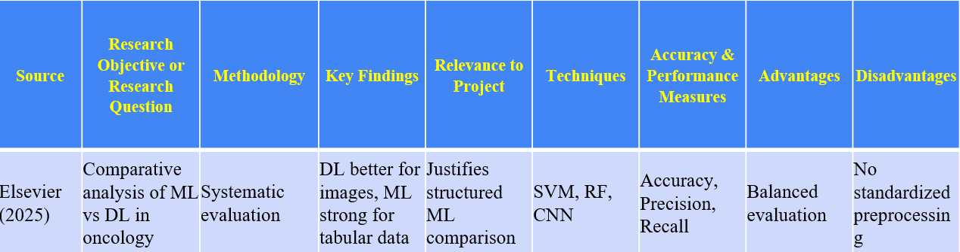

2.2 Summary: Drawbacks of Existing Approaches
- Although machine learning methods have led to a big advancement in classification of tumors, a number of constraints are noted in the current methods.
- Most of the papers are devoted to the implementation of a single or two machine learning algorithms instead of a comparative analysis of them. This reduces the knowledge of the performance of various models under identical conditions and it is hard to determine which algorithm is the most reliable.
- The other significant weakness is that various scientific studies assess the performance of models mainly through accuracy. In medical diagnosis, accuracy is not a sufficient metric, because other metrics like precision, recall, and F1-score are as well, particularly in reducing false negatives in detecting malignant tumor.
- Deep learning-based methods are highly accurate but need huge annotated datasets and substantial amounts of computing power. That renders them not so useful to small-scale projects or resource-limited environments. Moreover, such models tend to be black-box systems making them less interpretable.
- Most of the existing research relies on manual model selection and hyperparameter tuning, which is subject to domain knowledge and makes implementation more complex. The unfair comparison and unreliable results also result because of inconsistent preprocessing methods in different models.
- The second constraint is the inability to focus on the accuracy, interpretability and computational efficiency. There are models that have high accuracy but hard to interpret, a critical consideration in medical use.
- In addition, some studies do not test the generalization ability of models after they have been tested on small sets of data. This compromises the accuracy of the models in the real world situation.
- Lastly, the absence of a standardized and organized system that compares various machine learning models on the same preprocessing and evaluation terms is also lacking. This leaves a vacuum of coming up with the most effective and reliable model to classify tumors.

Research Gaps:
- A significant number of studies apply single or fewer ML algorithms, without a general comparative study.
- Most studies rely on manual model selection and hyperparameter optimization, which rely on time and expertise.
- Some of the works consider only accuracy to assess models, and other important metrics such as Precision, Recall, and F1-score are neglected.
- Many models are only tested on small or specific datasets, which restricts real-world generalization.
- The deep learning methods are resource-intensive in terms of both data and computing power, and might not be feasible in all locations.
- The drawback is that little attention is paid to such a balance between accuracy, computational efficiency, and model interpretability in medical diagnosis.
- The number of studies that compare ML models in the same conditions systematically is low.

CHAPTER 3

PROPOSED METHOD

3.1 Modules in Proposed Work
The proposed system is broken down into several modules with each module carrying out a particular task in the tumor classification pipeline. This modular design makes it transparent, scalable, and efficient to process medical data. The major modules in the system are the following:
Data Collection and Pre-processing Module
This module will be in-charge of obtaining and processing the tumor data to be analyzed further. The dataset is Breast Cancer Wisconsin dataset that includes structured numerical features of tumors.
The module cleanses the data by filling in the missing values as well as dropping irrelevant attributes. It will also standardize all features with StandardScaler to get all features on the same scale. The dataset is also divided into training and testing set based on stratified selection to ensure that the classes are balanced.
Module of Feature Engineering and Transformation.
The module is about transforming input features to the appropriate format to be used by machine learning models. It makes certain that every feature is standardized and without inconsistencies.
Scaling of features is used to enhance performance of the model, particularly, distance-based algorithms such as KNN and margin-based models such as SVM. The module also prepares the feature array (X) and target variable (y) to be efficiently trained and evaluated.
Model Training Module
The Model Training Module uses several supervised machine learning algorithms to classify tumors.

The models which are used in this project are Logistic Regression, Support Vector Machine, K-Nearest Neighbors, Decision Tree, and Random Forest. All the above-mentioned models are trained on the same preprocessed dataset to compare them on equal terms. This module allows determining the weaknesses and strengths of various algorithms.
Validation and Optimization Module.
The module will improve the performance and reliability of the model by using validation and tuning.
It applies 5-fold cross-validation to make sure that the performance is similar in the various data splits. GridSearchCV is used to optimize model hyperparameters, including SVM kernel type, regularization strength and tree count in Random Forest, through hyperparameter tuning. This assists in minimizing overfitting and enhancing generalization.
Performance Evaluation Module
This module measures the trained models on several performance metrics to have a comprehensive measurement.
Measures like Accuracy, Precision, Recall and F1-Score are computed. Confusion Matrix is created to examine the classification errors, especially false negatives in the detection of malignant tumor. Also, the ROC curves and AUC scores are used to assess the capacity of the model to differentiate between classes.
Error Analysis Module
This module discusses misclassifications of the models in order to learn their limitations.
False negatives are also considered with special attention given to them as they are malignant tumors that have been wrongly diagnosed as benign. The module analyzes situations in which values of features are similar or ambiguous patterns to enhance the effectiveness of the model selection and reliability.
Interpretability Module
Interpretability Module gives an understanding of the decision-making process of the models.
The Random Forest model is extracted to obtain feature importance and coefficients generated by Logistic Regression are examined to determine the most impactful tumor attributes. This increases the level of transparency and builds confidence in the model, which is essential in medical practice.
Model Selection and Deployment Module
In this module, the most effective model is selected due to balanced evaluation metrics, and it is prepared to be implemented in practice.
The model that is selected is not only selected by the accuracy factors but also in terms of recall and stability to reduce the risk of medical diagnosis. The last model can be implemented as a real-time tumor classification and decision support.

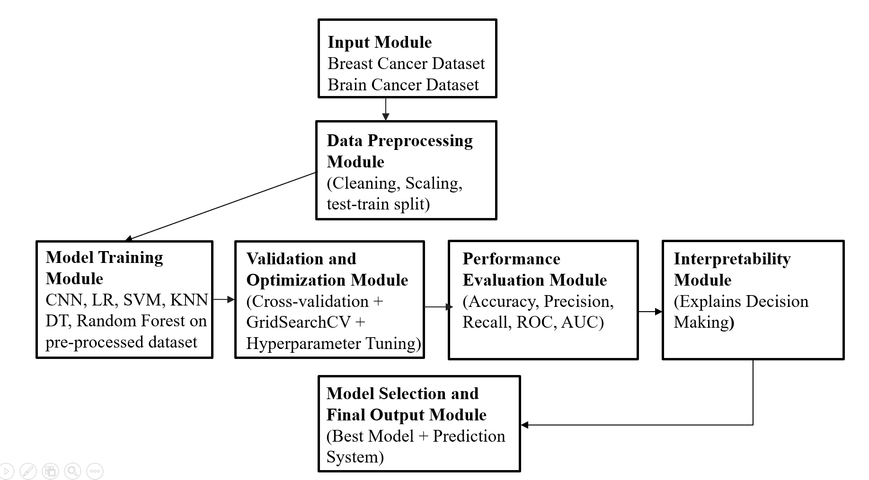
3.2 Analysis and Design through UML
The following diagram (Figure 3.2.1) illustrates the class diagram of the proposed Tumor Classification System, in terms of the static structure. This model shows how the classes are connected within the system through the use of attributes, methods and relation between the classes. The system structure, information flows, and relationship between the different aspects of the tumor dataset processing, model training, and performance evaluation can be comprehended easier with the assistance of the class diagram.
The type of user is the one who communicates with the system. Attributes of a user are userId and userName. The user procedures are uploadDataset() and viewResults that enable users to provide tumor dataset and see the final classification results with the best-performing model and its performance metrics. The class TumorDataset is interacted with by the user because the uploaded dataset is the most important key input into the system.
TumorDataset is the medical dataset that is presented by the user. It has the following properties: datasetId, filePath and datasettype. This class mainly loads the dataset using the loadDataset() method. The course is closely related to Preprocessor as the first step in processing the raw tumor data is the essential preprocessing, which makes the input ready to be used to train the machine learning models.
Class Preprocessor will be in charge of data cleaning and preparation. Its functions are handleMissingValues, normalizeFeatures and stratifiedSplit. These functions process the raw dataset into a clean and normalized dataset which is suitably divided. The Preprocessor ensures a balanced and fair base of all subsequent models training by eliminating inconsistencies and scaling the features using StandardScaler.
Class LogisticRegression is a linear baseline classifier. It employs a sigmoid curve to find the likelihood of a tumor being benign or malignant. Its train() and predict() methods train binary and have interpretable feature coefficients which can be compared with more sophisticated models.
SVM (class SVM) is a classification technique with margins. It uses high-dimensional feature space to identify a best hyperplane that classifies tumors. The two functions train and predict are used to classify using the kernel, and hyperparameter optimization is used to optimize the regularization parameter, C, and the choice of kernel to achieve the best classification results.
Class KNN does the distance-based classification that assigns class labels based on the majority vote of the nearest neighbors in the feature space. Its training and prediction functions are also sensitive to scaling the features and the normalization step in the Preprocessor is particularly critical to this model.
Class DecisionTree builds a hierarchical tree of rules based on thresholds of features to identify benign and malignant tumors. Its predict() and train() functions generate a model that is easily interpretable and it overfits easily unless depth constraints are enforced.
Class RandomForest is an ensemble learning model which takes a combination of many decision trees in a bagging method to enhance stability in classification and minimize overfitting. Also, it provides the method predict besides train, allowing it to get FeatureImportance, thus identifying the most influential tumor attributes in making classification decisions.
All the trained models are combined in the ModelSet class. ModelSet stores trainedModels, modelNames, predictions, crossValScores, and offers a consistent view of the trained state of the system. This provides a full depiction of the classification pipeline and is the key input of the downstream evaluation and optimization modules.
Class ValidationOptimizer enhances the reliability of the models with applyKFoldCV() and optimizeHyperparameters(). Five-fold cross-validation makes certain that there is stability in the performance results and that it is not reliant on a single train-test split. Both SVM and RandomForest are hyperparameter tuned with GridSearchCV, to determine the best settings.
Class PerformanceEvaluator can be used to test quality of each trained model by means of computeMetrics(), plotConfusionMatrix, and plotROCCurve. The metrics used in evaluation are Accuracy, Precision, Recall and F1-Score. The analysis of the confusion matrix is specifically oriented to reducing the number of false negatives in the detection of malignant tumors since a misdetection of a malignant tumor as a benign one is still a high-risk clinical outcome. Additional data on the capability of the model to classify classes is offered by ROC curves and AUC scores.
The result object is stored in Result class. Result includes bestModel, accuracyScores, rocAucScore, and featureImportance, which combines all the analytical results into one structured object which facilitates clinical decision-making based on the data.
The class diagram shows the way the tumor classification system works as a programmable pipeline. Upon uploading a dataset, preprocessing, model training, cross-validation, performance evaluation, and selecting the final model all go through. Each class manages a specific step, making the system scalable and structured. Also using the design changes can also be made to the component without affecting the remainder of the pipeline.
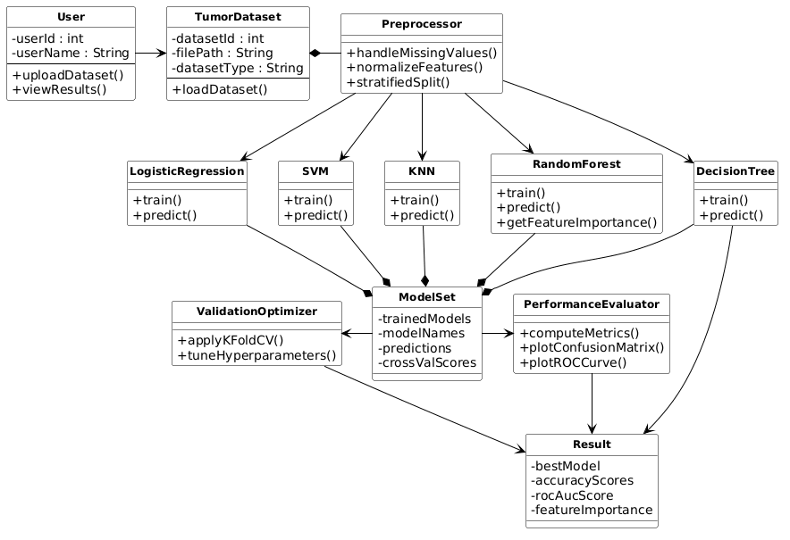

SEQUENCE DIAGRAM
The below figure shows the interrelations between the various components of the Tumor Classification System. It is the series of processes that take place when a user submits tumor information and asks it to be classified. The diagram demonstrates clearly the way different modules will interact to process the data step-by-step so that efficient classification results can be obtained.
The Tumor Classification System is composed of various modules, including data input module, preprocessing module, model training module, validation module, evaluation module, model selection module, and result display module. These modules are sequential in that each of the modules completes a particular task to guarantee accurate and reliable classification of tumor.
Input Phase: The steps start with uploading the tumor dataset into the system by the user. This information serves as the main input and it is forwarded to the data processing module. The dataset is sent to the system where it is transmitted to the preprocessing module to be processed.
Preprocessing Phase: During this stage, the data is cleaned and made ready. This module takes care of missing values, data inconsistencies and normalizes the data through methods including StandardScaler. This guarantees that the features are all on equal scales and compatible with machine learning models. The normal and cleaned data is subsequently sent to the next phase.
Model Training Phase: The processed data is sent to the model training module. Various machine learning algorithms are implemented in this module, such as Logistic Regression, Support Vector Machine (SVM), K-Nearest Neighbors (KNN), Decision Tree, and Random Forest. All models are also trained with the same dataset, so that they are fairly compared. This step assists in acquiring trends out of the tumor characteristics.
Validation and Optimization Phase: The models are then trained and sent to the validation module. In this module, 5-fold cross-validation is used to ascertain the validity of models. It also does hyperparameter tuning on the basis of GridSearchCV in order to optimize the performance of the model. This measure assists in lessening overfitting and enhances generalization.
Performance Evaluation Phase: The developed and validated models are then tested on various performance measures. Accuracy, Precision, Recall, and F1-Score are computed by the evaluation module. It also produces a confusion matrix to examine errors of classification and draws ROC curves to assess the performance of a model. This step will make sure that there is a thorough comparison of all models.
Error Analysis Phase: The system will then examine the erroneous classification, particularly the false negatives in which the malignant tumors may be classified as benign. This stage is vital in medical practice since it directly influences reliability of diagnosis. The system determines the causes of errors like overlapping feature values or limitation of data sets
Model Selection Phase: Once the evaluation is done, all performance metrics are forwarded to the model selection module. This module uses the balanced metrics, especially focusing on the recall and stability, to choose the best performing model. The aim is to select a model which minimizes the critical errors and high accuracy is maintained.
Result Generation Phase: The final tumor classification results are obtained by the selected model. The output will be classified into predicted class labels (Benign or Malignant) and performance metrics such as accuracy, precision, recall, F1-score, and ROC-AUC score.
Output Phase: Finally, in the output phase the results are displayed to the user. The system shows the outcome of classification, evaluation metrics, and insights in a simple and easy to understand format. This allows the user to easily interpret the tumor classification and the decision-making.

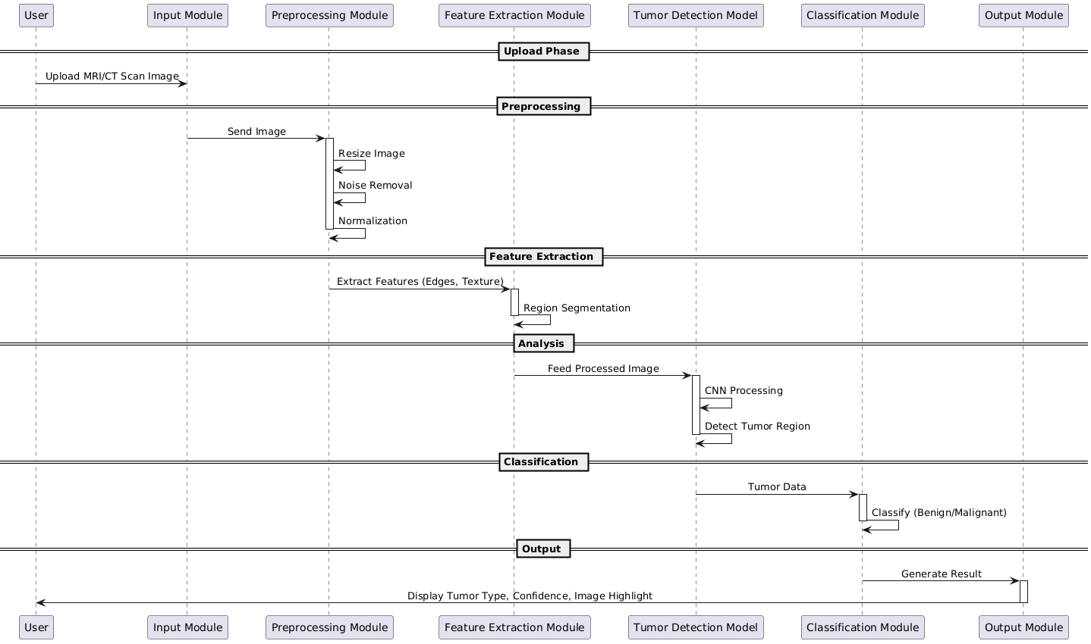
USE CASE DIAGRAM:
This project introduces a Tumor Classification System, which enables the user to automatically analyze medical data and classify tumors as benign or malignant with machine learning methods. The system aims to help with proper and effective diagnosis, decreasing the level of manual work and enhancing the consistency of analysis.
The main consumer of the system would be a user who desires to classify tumor data without having to analyze the complicated medical features manually. This can be a medical practitioner seeking rapid diagnostic services, a researcher who is processing tumor data, or a student processing medical data.
It has one of the key use cases and it starts when the user pushes a tumor dataset into the system. This data set has numeric properties including tumor properties like radius, texture, perimeter and area. Once the dataset is uploaded, the system automatically starts processing it.
The initial step is the preprocessing of the data, including cleaning up of the missing values, detection of inconsistencies and normalization of the features to achieve consistency. The system uses various ML algorithms like Decision Tree, K-Nearest Neighbors, Logistic Regression, Support Vector Machine, and Random Forest to analyze the data after preprocessing it.
During the training and evaluation of the models is done the system computes different performance measures such as accuracy, precision, recall, and F1-score. It also creates confusion matrices and ROC curves to improve the understanding of model performance and find possible errors, particularly false negatives on detecting malignant tumors.
After the evaluation of the models, the system creates the most performing model on the basis of balanced metrics. The ultimate outcomes are the estimated tumor (benign or malignant), performance, and understanding of how the models behave.
Besides classification, the system is also interpretable and reveals the key characteristics of tumors that affect the prediction. This makes the users know how the model has come to make a choice.
It is also possible to consider an admin position within the system. The admin will take care of the dataset and as time passes, update the machine learning models and enhance system performance.
Finally, the case study illustrates how the Tumor Classification System can be used to analyze tumors in an efficient, accurate, and automated way. It minimizes the workload of a person, enhances reliability, and assists data-driven decision-making in medical use.
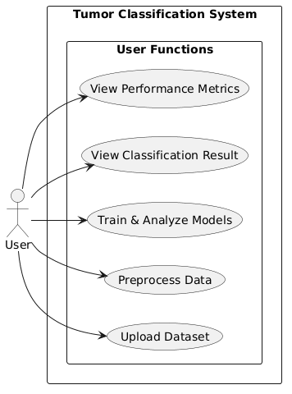
ACTIVITY DIAGRAM
Activity diagram depicts the entire workflow of the Tumor Classification System, and all the steps and decision points in the published analysis of tumor data. It assists in grasping the manner in which the system takes input information, analyses it, and produces final results in terms of classification. This diagram assists in the clear and structured explanation of dynamic behavior of the system.
The Start node will be the starting point in the process, during which the user will trigger the system by uploading a tumor dataset. The input handling module gets this information and confirms the data is in the right format and can be processed.
Data Preprocessing Stage: After the validation of the input, the system proceeds to the preprocessing stage, necessary to prepare the data. Here missing values are dealt with, irrelevant/inconsistent data is discarded, and all features are normalized with tools like StandardScaler. This helps to ensure that the data is clean, consistent and shaping to be read by a machine learning.
Parallel Draining and X-ray Training and Analysis: The workflow delivers numerous parallel branches after preprocessing in which various machine learning models are run concurrently. Such models as Logistic Regression, Support Vector Machine (SVM), K-Nearest Neighbors (KNN), Decision Tree and random Forest are included.
Both models are able to learn tumor patterns/data individually and classify. Meanwhile, all models have performance metrics that include accuracy, precision, recall and F1-score computed. This parallel processing optimizes performance and enables a reasonable basis of comparisons between different algorithms.
Error Analysis and Evaluation: After all of the models have made their forecasts, evaluation takes place. The results of classification are analyzed by creating confusion matrices, and a special focus is made on the false negatives (malignant tumors wrongly defined as benign). ROC curves and AUC scores are also calculated to give the general performance of the models.
Feature Integration: Once the models have been evaluated, the results of each model are merged into a single feature set, performance measures and error analysis outcomes. This will help to make certain that all the information that is needed is under a single place where a decision will be made.
Model Selection Phase: The system then goes on to pick out the most performing model. This choice rests on equal evaluation measures, but the emphasis is more on recall and reliability to reduce critical missteps in medical diagnosis.
Result Generation: Upon the selection of the best model, the final classification results are produced using the model. The model results the prediction of the tumor type either benign or malignant, and the performance metrics are accuracy, precision, recall, F1-score, and ROC-AUC.
Output Phase: Lastly, the system shows the results in an effective and easy to comprehend format to the user. This contains classification outcome, performance diagnostics and some ideas about model behavior.
The End node marks the end of the working process, and it shows that it was completed successfully. In general, the activity diagram illustrates an effective and well-working system that utilizes parallel processing and the use of multiple machine learning models to obtain reliable and high-quality tumor classification.
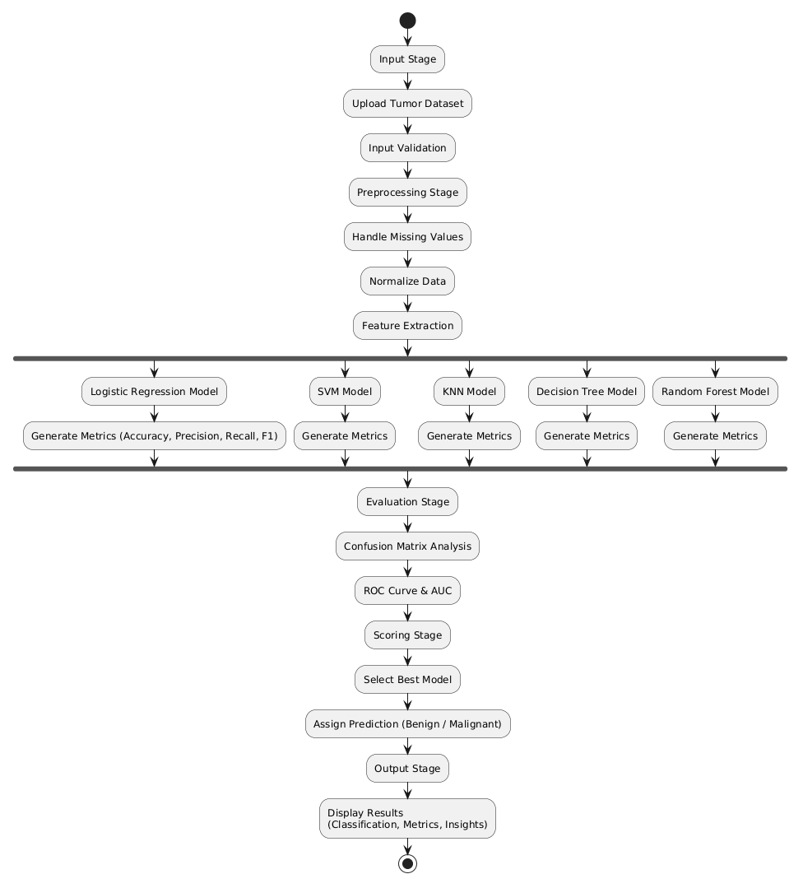
3.3 Requirements Engineering
Functional Requirements:
Dataset Upload / INP.
The system will enable users to post tumor data in systematic formats (including CSV). It will check the input data to guarantee that it is accurate and complete and then proceed.
Data Preprocessing
The system will preprocess the dataset, including performing paint similar functions on missing values, removing inconsistencies, and normalizing features, through methods like StandardScaler. It will put the information in a machine learning model-friendly format.
Feature Handling
The system will divide the dataset into the target labels (y) and feature variables (X). It will make sure that each of the features is appropriately scaled and formatted to train models.
Model Training
To classify tumors, the system will include several machine learning-based algorithms such as the Logistic Regression, Support Vector Machine (SVM), K-Nearest Neighbors (KNN), Decision Tree, and Random Forest algorithms.
Validation and Optimization
The cross-validation techniques to be used in the system (5-fold cross-validation) to guarantee reliability of the models. It will also carry out hyperparameter optimization via the GridSearchCV to enhance the performance of the model.
Performance Evaluation
The system will measure all models based on their performance metrics such as Accuracy, Precision, Recall, and F1-Score. It will also produce confusion matrices and ROC curves to examine performance of classification.

Error Analysis
The system will be used to analyze false classification, specifically false negatives (malignant tumors which were taken as benign). It will give us a clue on the possible causes of mistakes.
Model Selection
The system will be able to pick the highest performance model, using balanced assessment measures, which will produce high accuracy and reliability in medical diagnosis.
Result Generation
The system will produce the end result of the tumor classification (Benign or Malignant) plus performance measures and evaluation indicators.
Visualization / Output Display
The system will deliver results in simple and organized format with classification results, performance measurement, and analysis insights in a manner that enables easy interpretation.

Non-Functional Requirements
Performance
The system is to run through tumor data and categorize the results efficiently and with a reasonable time.
Scalability
The system must be able to manage bigger data-sets and a variety of classification activities without a major decrease in its performance.
Accuracy and Reliability
High accuracy and reliability in the classification of tumors must be ensured by well-trained machine learning models.

Usability
The system must have a user-friendly interface enabling users to simply upload data, results and to explain outputs.
Explainability
To increase transparency to the user, the system must give insights regarding the decisions of models, such as feature's important and performance analysis.
Robustness
The system must be able to deal with missing or noisy data and still give meaningful results.
Modularity
This system must be based on a modular design that separates preprocessing, training, evaluation and output modules to enhance their maintainability.
Compatibility
The system must be able to take common data formats (e.g. CSV) and work in general computing environments.
Security
This system must contain a prescription that the information uploaded cannot be accessed by any other party.
Maintainability
The system must provide easy modifications of models, datasets and algorithms to enhance performance as time goes by.

3.4 Software and Hardware Requirements

Software Requirements | Hardware Requirements
Operating System: Windows 10 / 11 / Linux / macOS | Processor: Intel i5 / i7 or Ryzen 5 / 7 or higher
Programming Language: Python 3.8 or higher | RAM: Minimum 8 GB (Recommended 16 GB)
Frontend (Optional): HTML, CSS, Streamlit / Flask | Storage: Minimum 10 GB free space (SSD recommended)
Libraries: Scikit-learn, Pandas, NumPy, Matplotlib, Seaborn | Optional: GPU not required (can be used for faster computation)

Software and Hardware Description
Tumor Classification System is Python-based because it is very supportive of machine learning and data analysis. Classification models are implemented in libraries like Scikit-learn, whereas preprocessing of data is done using Pandas and NumPy. Visualization is supported with Matplotlib and Seaborn, a basic user interface can be provided using optional frameworks such as Streamlit or Flask.
The system is capable of working well with a conventional computer with an Intel i5/Ryzen 5 processor, minimum of 8 GB (maximum 16 GB) of memory, and about 10 GB of free storage. Given that the project is based on classical machine learning on structured data, there is no need to have a GPU, although it can be optional to speed up the process.

CHAPTER 4

RESULTS AND DISCUSSION

4.1 Description about Dataset
The proposed Tumor Classification System is based on the Breast Cancer Wisconsin (Diagnostic) Dataset, one of the most popular medical datasets in machine learning studies. It is publicly accessible and comprises of well-organised numerical information obtained out of digitized pictures of breast tumor samples.
System 569 examples of tumor samples, including 357 benign and 212 malignant. Each sample is characterised by 30 numerical features which are representative of different aspects of the tumour, including radius, texture, perimeter, area, smoothness, compactness, concavity, symmetry and fractal dimension. These values are calculated as the mean, standard error and worst-case of each tumor.
This data set is highly structured as compared to the unstructured medical report; hence is suited to the use of classical machine learning algorithms. The numerical characteristics of the data enable effective preprocessing, such as normalization and feature scaling, one of which are obligatory in models such as SVM and KNN.
What is significant with the dataset is that it is clean and well balanced with few missing values which has assisted it in obtaining credible model performances. The dataset also represents actual diagnostic situations in the real world when a tumor classification will be conducted on the basis of measurable features, which are taken out of biopsy images.
The variable of interest in the dataset is two classes:
Benign (0) – non-cancerous tumors
Malignant (1) – cancerous tumors
This renders the problem a binary classification problem, the goal of which is to provide correct distinction between benign and malignant cases.

All in all, the dataset makes a good base to train and evaluate various machine learning models. The system allows the accurate classification of tumors and facilitates medical decision-making based on the data as its structured form, meaningful characters, and relevance to the real world provide opportunities.

4.2 Detailed explanation about the Experimental Results
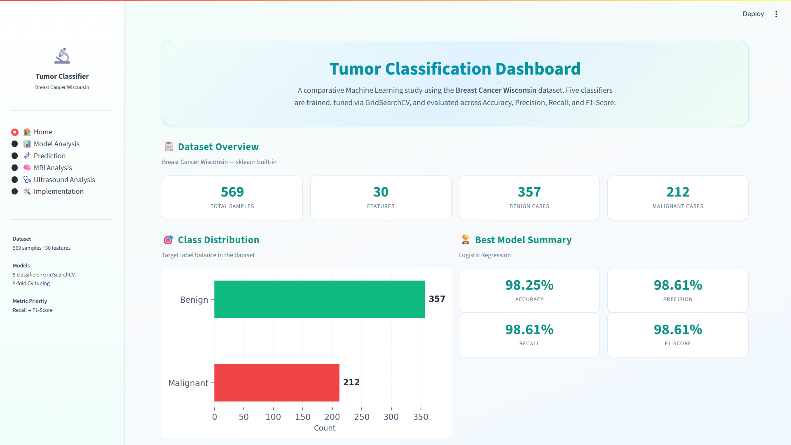

The figure above shows the Dashboard Page of the Tumor Classification System that is a centralized view of analyzing and comparing machine learning models performance. It presents a tabular view of the data set, classification findings, and measure performance, allowing users to easily assess the performance of various models in the tumor classification task.
On the top of the dashboard, a short summary of what the system is all about is provided in a description overall stating that various machine learning models are trained and optimized with the use of the GridSearchCV. The key metrics used to evaluate the models include Accuracy, Precision, Recall and F1-Score that provide users with the clear picture of the evaluation method applied in the system.
The Dataset Overview section shows the major statistics of this dataset such as sample, assessing the number of samples, number of features and the amount of benign and malignant cases. This will make users know the dimensions, form and content of the dataset they made to train the models with.
The section Class Distribution illustratively displays the distribution of classes of the tumors on a bar diagram. This enables people to view the balancing between benign and malignant cases easily, crucial in making the models behave fairly and impartially.
The Best Model Summary lists the most successful model by evaluation measures. In this scenario, the most effective model is the Logistic Regression, which has great values in Accuracy, Precision, Recall, and F1-Score. These measures are presented in an easy-to-understand format, and one can easily determine how effective the model is.

There are also other options of navigation in the sidebar like Home, Model Analysis, Prediction, MRI Analysis, Ultrasound Analysis, Implementation. These features improve usability because they enable users to search the various elements of the system making the dashboard user-friendly and informative to study and make decisions.

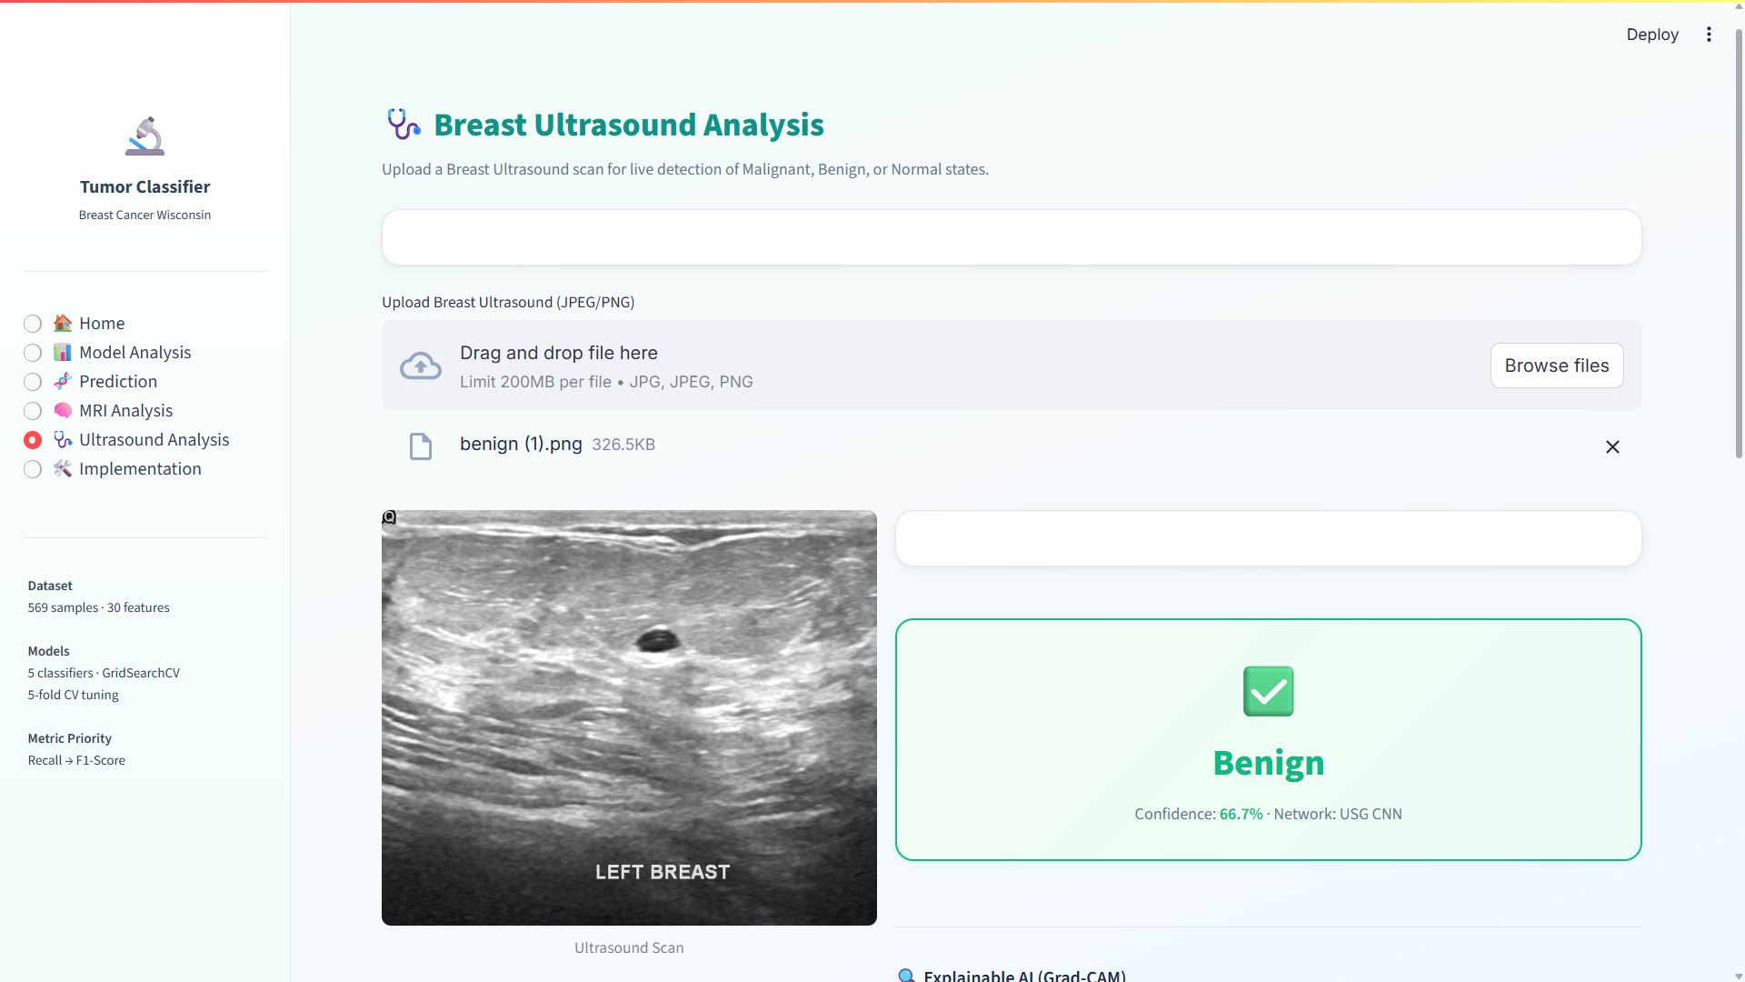
The above picture shows the Breast Ultrasound Analysis Page of the Tumor Classification System offering an interface to study ultrasound images and foretell the tumor conditions. The module allows users to post the breast ultrasound scans and obtain automatic predictions on whether the tumor is benign, malignant, or normal.
There was a brief description at the very beginning of the page, and its goal was to classify images using real-time images, with a focus on image classification. The system is compatible with most popular image formats like JPG, JPEG, and PNG, so the users can easily upload ultrasound scans.
The interface is user-friendly with a file upload section, where users can drag and drop pictures of browse files on their computer. After uploading, the ultrasound image is shown on the screen and one can verify the input to analyse it.
Once the image has been processed, the system thinks with the help of a trained CNN model and creates the predictions. The result is presented visually in a section that is highlighted and the word output represents the predicted class, which in this case, is Benign, followed by a score in terms of confidence, which is the level of confidence the model has.
In general, this page shows that the system processes medical images along with machine learning to provide an effective and quick tumor classification. It offers simple analysis in complex and easy to understand format that can be applied to learn and apply.
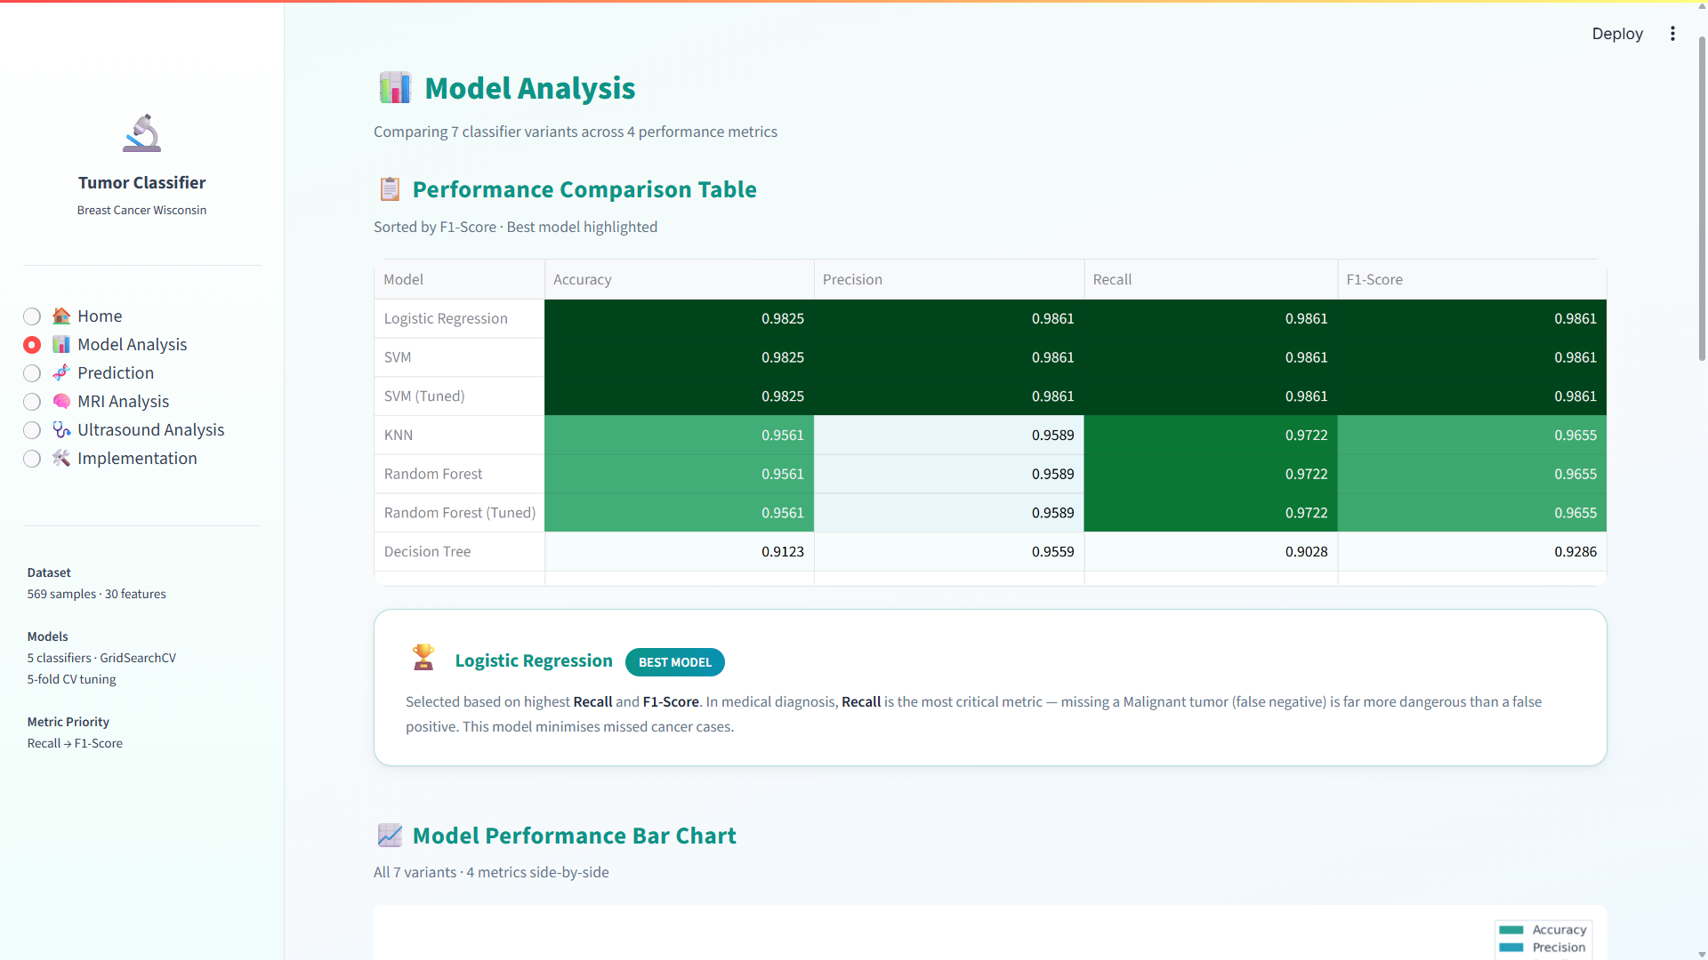
The Figure above shows the Model Analysis Page of the Tumor Classification System, where you will find a more detailed comparison of the various machine learning models that can be used to classify tumors. This page helps users evaluate and understand the performance of different classifiers based on various evaluation metrics.
The top description outlines briefly that a number of versions of the classifier are compared based on the key measures of Performance in terms of Accuracy, Precision, Recall, and F1-Score. The Performance Comparison Table shows all these metrics in each model and enables the user to readily compare the effectiveness of each model. It is sorted according to F1-Score and the most successful model is visually indicated in order to be identified more easily.
Based on the comparison, models like the Logistic Regression and the SVM obtain the best performance, and the scores are constant and high in all the measures. Models such as Decision Tree, in contrast, demonstrate relatively poorer performance suggesting the potential of overfitting or incapability to process the data. This comparison aids users to clearly establish the most reliable models that can be used to classify tumors.
The Best Model Summary section has mentioned the Logistic Regression as the best working model. It states that the choice is made on the factors of higher Recall and F1-Score which are important when making a diagnosis in medicine. Because the consequences of a false negative (a malignant tumor) can be severe, it is better to have a more safer and more reliable prediction which is guaranteed by Recall.
Also, there is a page consisting of a Model Performance Bar Chart, that clearly illustrates the performance of all the models in various metrics. With such a graphic representation, it is easier to discern changes between models and this leads to easier decision-making. On the whole, this page offers a detailed and easy to use discussion of model performance, assisting to a user in choosing the most appropriate model to use in tumor classification.

4.3 Importance of the Proposed Work with its Benefits

The proposed Tumour Detection System is particularly important because it offers an AI-based model of early detection and classification of tumours based on medical imaging data. In the current healthcare system, proper and timely diagnosis is a very important aspect in enhancing the survival rate of the patient. Nevertheless, radiologists may take time, be subjective when analyzing MRI or CT scan images manually, and may vary when analyzing faint tumour patterns. The offered system will solve these problems by combining the image preprocessing, feature extraction, deep-learning-based classification (including CNN models), tumour segmentation, and explainable AI methods into a single platform to increase the accuracy and efficiency of diagnostic results.

One of the main importance of this system is that it helps medical workers in diagnosing tumours at an early stage more accurately. The system helps to decrease the possibility of misdiagnosis and helps faster clinical decisions making by automatically identifying the presence of abnormal areas in medical pictures, categorising them as tumour types, and pointing out where affected areas are. This is especially useful in busy healthcare settings with high workload in which high-volume imaging data must undergo rapid and precise analysis.

The system has a number of benefits in real-life healthcare practice. It not only saves much work on radiologists since the arduous work of analyzing images is automated, but also enhances uniformity in diagnosis by reducing the number of human mistakes and provides objective assessment of the medical images. Moreover, it can be noted that the implementation of visualization and explainability modules will enable doctors to learn the logic behind predictions, which will enhance the trust in AI-assisted diagnosis. The system will also be able to assist in comparative analysis between patient scans to allow improved tracking of tumour growth or response to treatment over time.

The second significant benefit is that it can transform complicated deep learning outputs into an easy-to-understand user interface, thus it is not only accessible to specialists but also to general practitioners. This enhances access to higher-order diagnostic instruments in a resource-constrained environment where highly trained radiologists are not necessarily accessible. Moreover, the system can be expanded to multi-modal data (i.e. integration of imaging with clinical records) which increases its functionality in terms of overall medical evaluation.

All in all the proposed Tumour Detection System improves the accuracy, speed, and reliability of the medical diagnosis. It aids in better patient outcomes, facilitates effective healthcare delivery, and encourages the use of smart decision-support systems in clinical practice, which makes it very beneficial in real-life medical uses.

4.4 Limitations of the Proposed Work with its Shortcomings
The quality of input medical images like MRI or CT scans is important to the system performance. Poorly captured images, low-resolution and noisy images can significantly decrease the accuracy of detection.
The differences in imaging devices, scan regimes, and hospital quality can cause the input data to be inconsistent, which can impact the model generalization.
The model might not be able to detect very small tumours or early-stage tumours especially where contrast between normal and abnormal tissue is low.
Complex cases, where there are overlapping tissues or unusual shapes of tumours, can give erroneous results of segmentation or classification.
Deep learning model consumes a great deal of medical data that is labeled. Small or unbalanced datasets may decrease the reliability of prediction and augment bias.
The system can give false positives (when there is no tumour in a patient, it identifies the tumour) or false negatives (when a patient does have a tumour, the system fails to detect it), which can affect clinical decision-making.
Explainability methods give information on the model decisions, which might not necessarily be aligned with medical reasoning causing trust issues among medical practitioners.
This system mainly emphasizes imaging information and might not include the other significant clinical variables including patient history, laboratory reports, and genetic data.
The large computational needs to train and process large medical images can elevate the cost of the system and reduce the possibility of implementation in real-time and resource-constrained settings.

Connection with already installed hospital systems (there could be PACS or electronic health records) might be complicated and could need extra infrastructure.
The system might also struggle to cope with the rare tumour types or other unusual medical conditions as there is little training examples.
The diagnosis cannot be completely autonomous; it is supposed to be a decision-support system, which still needs to be verified by the medical community.

CHAPTER 5

CONCLUSION AND FUTURE ENHANCEMENTS

5.1 CONCLUSION
Overview of the Project.
The Tumour Detection System is a smart healthcare solution that will help accurately and efficiently identify tumours on medical images of any type, be it MRI or CT scan. This project is aimed at enhancing diagnostic reliability through application of superior deep learning methods to detect abnormal growths in the human body. The system processes medical images, points out suspicious areas, and presents the results of classification that can assist in establishing the existence and type of tumour. It is a helpful device to medical practitioners and saves on the manual work and enhances medical diagnosis speed.
Objectives
The overall objective of the Tumour Detection System is to create a powerful model that is capable of analysing medical images and locating tumours with maximum accuracy without human intervention. The system is supposed to categorise tumours into various groups (benign or malignant), divide the affected areas, and help the doctors to know the extent of the condition. It is also concerned with enhancing early detection, which is paramount in the treatment. The system also gives visual outputs and confidence scores to aid clinical decision making and improve diagnostic clarity.
Importance
As the number of cancer cases is constantly rising globally, there is high demand in the valuable and rapid diagnostic tools. The process of analyzing medical images manually can consume a lot of time and thus can depend on the experience of the radiologist. The Tumour Detection System is significant as it enhances to minimise diagnostic delays, human error, and provides uniform assessment of medical images. It may be particularly helpful in those regions, where there is a lack of skilled medical workers, and thus the quality of the medical services may be enhanced.

Significance
The importance of the Tumour Detection System is that it combines various AI methods into one system. It involves preprocessing of images, feature extraction, deep learning-based classification, and visualization to provide accurate results. The system improves transparency as it generates explainable outputs that demonstrate the way predictions are approached. The system can convert the complex outputs of the models into visual insights which can be understood, making it practical and useful in the real world clinical setting. It represents a medium between the high-level AI technology and the daily medical practice.
Approach Adopted
Tumour Detection System is structured in approach. The medical images are first preprocessed to eliminate noise and improve the quality. Next, the features are extracted and the images are classified with the help of deep learning models like Convolutional Neural Networks (CNNs). Tumour segmentation methods are used to detect and highlight the areas of the affected. The system then produces predictions and visual explanations and scores on confidence. This stepwise pipeline will guarantee a proper analysis and interpretations of medical data.
Qualitative Results
The system is successful in locating the tumour areas, detection of abnormalities and also indicating the key areas in medical images. It gives clear visual results that can assist doctors in knowing the location, and the nature of the tumour. The findings enhance interpretation and simplify the analysis of complicated medical data. Patterns can be easily observed and scans compared by the user and insights on the characteristics of the tumours are gained.
Quantitative Results
The Tumour Detection System shows good performance with respect to accuracy, precision and recall on tumour classification tasks. Deep learning models that are deployed in the system offer stable and accurate predictions of various datasets. The general results suggest that the system is effective in aiding medical diagnosis. It is a reliable device to help healthcare specialists in tumour detection and analysis, leading to enhanced patient outcomes.

5.2 Future improvement (Tumour Detection System)

The suggested AI-based Tumour Detection System is efficient and effective in the analysis of medical images, but there are a number of aspects, which can be improved, to make it more powerful, reliable, and applicable to the real world of clinical practice.
Improvement of Data Integration
Multi-source medical data integration is one of the significant improvements. The system is currently mostly based on imaging data (MRI or CT scans). It can be expanded to incorporate the medical history of patients, lab findings, biopsy findings, and genetic information in the future. This will allow a more thorough analysis and enhancing the accuracy of diagnoses by paying attention to both the imaging and clinical factors.
Advanced Multimodal Analysis
It is possible to enhance the system with the help of multimodal data analysis whereby various inputs of medical data are combined. As an example, the integration of radiology images with pathology slides or clinical notes can help gain a better understanding of the characteristics of tumours. It will be useful to implement computer vision and natural language processing methods in order to make the system interpret more complex medical data.
Improvement in Model Accuracy.
Future directions can be based on more complex deep learning models like hybrid CNN models, transformer-based models, or ensemble methods. The bigger and more varied datasets will aid in training that will enhance generalization and minimize bias. Mechanisms of continuing learning can also be provided to ensure that the model changes with time as it receives new information.
Real-Time Processing Capability
It is possible to improve the system to accommodate real-time tumour detection and tracking. It can also analyze scans in real-time as they are being produced by connecting with hospital imaging systems. This will assist physicians to make decisions quicker, particularly in the emergency cases, where diagnosis is very important.

Improved Explainability
Despite the fact that the system has visual outputs, the future versions can also be equipped with more sophisticated explainable AI methods. These improvements will be a clear indication of why a specific prediction was chosen, allowing important areas and aspects of the image to be pointed out. This will enhance confidence and embrace within medical professionals.
Scalability and Deployment Optimization.
The system needs to be optimized to be deployed in cloud and edge environments to make it widely usable. This will enable it to deal with volumes of medical data effectively and assist a number of hospitals or diagnostic centers at the same time. One of the priorities will be to reduce the computational cost without impacting on the performance.
Domain-Specific Knowledge.
Medical guidelines, clinical protocols, and expertise can be incorporated into the system to enhance it. This will assist in making sure that predictions are compatible with the standard diagnosis and enhance reliability of the system in clinics.
Expansion to Multiple Diseases.
The system is currently focused on the detection of tumours, but can be extended to detect other diseases including cysts, lesions or neurological conditions. This will make it a more all-inclusive diagnostic instrument.
Plugging into Healthcare Systems.
The system can be connected to hospital management system including Electronic Health Records (EHR) and Picture Archiving and Communication Systems (PACS). This will facilitate workflow and help healthcare professionals to use and access the system.
In general, Tumour Detection System has a great potential to be developed further. It can become a highly reliable and intelligent clinical decision-support system that can greatly improve healthcare outcomes by integrating updated technologies, increasing the number of sources of data, and ensuring usability.
CHAPTER 6

REFERENCES

// Sample Referencing Style for a Journal
- S. Kumar, P. Tiwari and M. Zymbler, “Internet of Things is a Revolutionary Approach for Future Technology Enhancement: A Review”, Journal of Big Data, Vol. 6, Article No. 111, pp. 1-21, 2019. https://doi.org/10.1186/s40537-019-0268-2

// Sample Referencing Style for a Webpage
- “Introduction To IoT | What Is IoT.” [Online]. Available: https://www.leverege.com /iot-ebo ok/what-is-iot#:~:text=%E2%80%9CThe%20Internet%20of%20Things%20 (IoT,%2Dto%2Dco mputer %20interaction.%E2%80%9D

// Sample Referencing Style for an Image
- What is the IoT? Introduction to the Internet of Things, [Online]. Available: https://medium.com/@bmuha1/what-is-the-iot-introduction-to-the-internet-of-things-57335391cd5f

APPENDICES

